Skin Disease Detection Using Image Processing with Data Mining and Deep Learning
Mrs. Jayashree Hajgude¹, Harsha Achara², Nisha Khubchandani³, Aishwarya Bhavsar⁴
¹Assistant Professor, Department of Information Technology, VESIT, Mumbai, Maharashtra, India
²Student, Department of Information Technology, VESIT, Mumbai, Maharashtra, India
³Student, Department of Information Technology, VESIT, Mumbai, Maharashtra, India
⁴Student, Department of Information Technology, VESIT, Mumbai, Maharashtra, India

---------------------------------------------------------------------***---------------------------------------------------------------------

Abstract - Skin diseases are hazardous and often contagious, especially melanoma, eczema, and impetigo. These skin diseases can be cured if detected early. The fundamental problem with it is, only an expert dermatologist is able to detect and classify such disease. Sometimes, the doctors also fail to correctly classify the disease and hence provide inappropriate medications to the patient. Our paper proposes a skin disease detection method based on Image Processing and Deep Learning Techniques. Our system is mobile based so can be used even in remote areas. The patient needs to provide the image of the infected area and it is given as an input to the application. Image Processing and Deep Learning techniques process it and deliver the most accurate output. In this paper, we present a comparison of two different approaches for real-time skin disease detection algorithm based on accuracy. We have compared Support Vector Machine (SVM) and Convolutional Neural Networks (CNN). The results of real-time testing are presented.

Keywords: Convolutional Neural Networks, Support Vector Machine, Eczema, Impetigo, Melanoma, Multilevel Thresholding, GLCM, 2D Wavelet Transform

1. INTRODUCTION

Skin diseases have a serious impact on the psychological health of the patient. It can result in the loss of confidence and can even turn the patient into depression. Skin diseases can thus be fatal. It is a serious issue and cannot be neglected but should be controlled. So it is necessary to identify the skin diseases at an early stage and prevent it from spreading. Human skin is unpredictable and almost a difficult terrain due to its complexity of jaggedness, lesion structures, moles, tone, the presence of dense hairs and other mitigating confusing features. Early detection of skin diseases can prove to be cost effective and can be accessible in remote areas. Identifying the infected area of skin and detecting the type of disease is useful for early awareness. In this paper, a detection system is proposed which enables the users to detect and recognize skin disease. In this system, the user has to provide the image of the affected area, the input image then undergoes preprocessing which involves filtering to remove the noise, segmentation to extract the lesion and then feature extraction to extract the features of the image and finally classifier to detect the affected area. For classification, Support Vector Machine (SVM) is used. On the other hand, deep learning algorithms have a competency to handle large datasets of complex computation hence, Convolutional Neural Network (CNN) is also implemented as a part of research area to detect the affected area of skin. Comparison between SVM and CNN is also represented with accuracy and confusion matrix. This paper proposed the solution for detecting the skin diseases viz. Melanoma, Impetigo and Eczema.

2. ARCHITECTURE

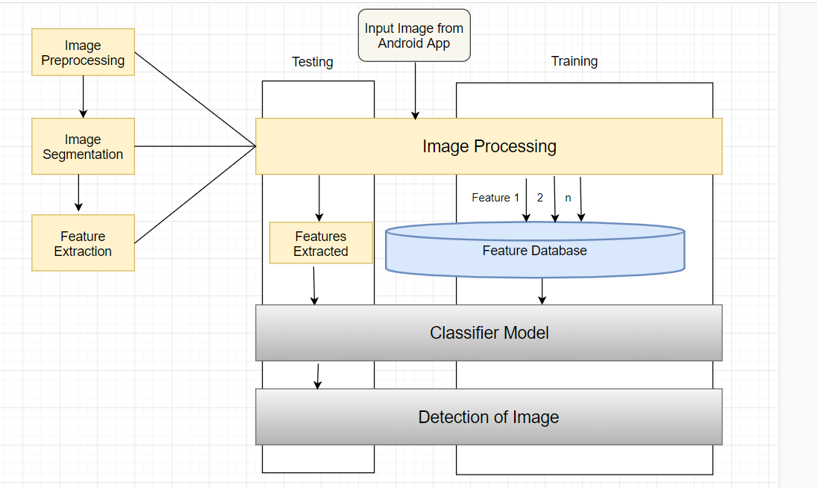
Fig -1: Architecture of System

A. User uploads image of the affected area using the mobile application
B. Image processing unit receives uploaded image at the backend where following steps will be performed on image.
a. Pre-processing of image
b. Segmentation to extract skin lesion
c. Feature Extraction to extract the features
C. Classification model uses extracted features for detection of affected area.
D. Result will be shown to the user in mobile application.

3. IMPLEMENTATION METHODOLOGY

Our proposed diagnosis system mainly consists of 2 main components

3.1 Image Processing Unit
Image Acquisition: Images are acquired through a camera or locally stored device. Images are obtained from surveys and websites.
Image Pre-processing: For Pre-processing of Image, Filtering is performed on image which is a non-linear process used for enhancing the overall image by preserving the edges of the image. Median filtering is used especially to reduce impulsive, salt-pepper noise. In this, each pixel value in an image is replaced with the median value of its neighboring pixels including itself.
Image Segmentation: Image segmentation is performed to separate suspicious lesion from normal skin. This is implemented through MATLAB. For image segmentation, multilevel thresholding using Otsu method is performed where image is segmented into 3 levels using IM Quantize with 2 threshold level. The Segmented image is converted into a color image using label2rgb().
Feature Extraction: Unique features of skin lesion are extracted. Features are extracted using the 2D Wavelet Transform. Features extracted using the wavelet transform are Entropy, Mean, Mean Absolute Deviation, Median Absolute Deviation, Energy, Standard deviation, L1 norm, L2 norm, Kurtosis, Skewness. Texture Features extracted using GLCM are Contrast, Correlation, Energy and Homogeneity.

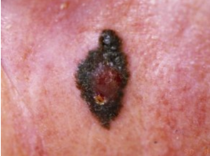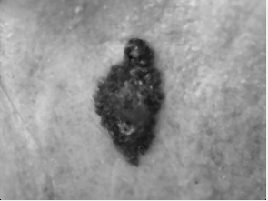

Fig -2: Original Image Fig -3: Filtered Image

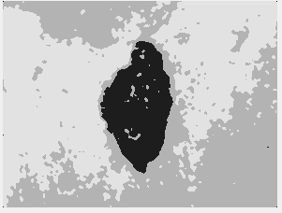

Fig -4: Segmented Image

3.2 Data Mining Unit

Data Mining is often described as the process of discovering patterns in large sets of data. For detection of skin disease, patterns obtained through the data are used. The data in the dataset comprises of visual features (features extracted from images using image processing). For skin disease classification, Support Vector Machine (SVM) classifier and Convolutional Neural Networks (CNN) classifier is used. Comparison of both the classifiers based on accuracy is shown with the help of confusion matrix.

3.2.1 Support Vector Machine

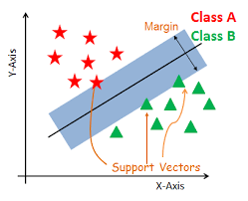
Fig -5: SVM

The support vector machine is a supervised learning model used for optimization. It is a unified framework in which different learning machine architecture can be generated through an appropriate choice of kernels. The principal used in SVM is statistical and structural risk minimization. The SVM is already a ready-to-use available classifier in MATLAB. After the feature extraction process, the extracted features are directly fed into the SVM classifier. The process involves two phases:
Training Phase: 408 images of eczema, impetigo, melanoma, and others are used for training.
Testing Phase: In this phase, test images are given to the classifier and the classifier uses knowledge gained during the training phase to classify the test image.

3.2.2 Convolutional Neural Network

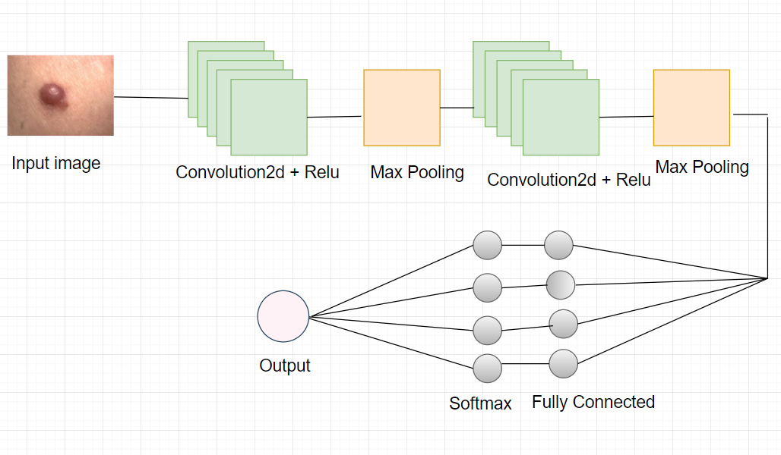
Fig -6: CNN Architecture

A convolutional neural network (CNN) is slightly in variance with the multilayer perceptron. A CNN can have a single convolution layer or it can contain multiple convolution layers. These layers can be interconnected or pooled together. A convolution operation is performed on the input and then the results are passed to the further layers. Thus, due to this, the network can be deep but will contain only a few parameters. Due to this property, a convolutional neural network shows effective results in image and video recognition, natural language processing, and recommender systems. Convolutional neural networks give accurate results in semantic parsing and paraphrase detection. This is the main reason to use CNN for skin disease detection. After experimenting with SVM classifier, CNN classifier is implemented to train and test skin disease images. Unlike SVM classifier, there is no need to perform processing steps on image. In SVM classifier, an image needs to be processed using image processing unit and then given for the classification to SVM classifier. CNN classifier is implemented in such a way where there is no need of image processing module. CNN classifier is a layered architecture where multiple layers perform various operations to train and test the image data. In this proposed solution, 408 images are given to CNN classifier for training where images for training are given to Convolution2dLayer. This is the first layer to extract the features from the input image. This layer applies a convolution operation and gives the result to the next layer and applies convolutional filters to the input. It computes the dot product of the input and weights and then adds a bias term. Then ReluLayer is introduced which is Rectified linear Unit Layer for handling nonlinearity in the network. MaxPooling Layer reduces the dimensionality of image and is used to divide the input into rectangular regions and computes the maxima of each region. After this operation, FullyConnected Layer multiplies an input with weight matrix, adds bias vector and it is responsible for creating a model for classification layer by applying Softmax Layer. Softmax Layer is a logistic activation function which is used for multiclass classification. Finally Classification Layer will detect the affected area of image and gives the output.

4. RESULTS

Disease | SVM | CNN
Eczema | 94% | 100%
Impetigo | 100% | 98%
Melanoma | 99% | 99.4%
No Disease | 52% | 98.8%
Overall Accuracy | 90.7% | 99.1%

Table -1: Accuracy Table

It is observed from above table that CNN Algorithm has near perfect accuracy in detecting skin diseases. The confusion matrix shows the percentage of error and accuracy in classification. It also shows corrected and uncorrected results, true positives, false negatives and number of classes.


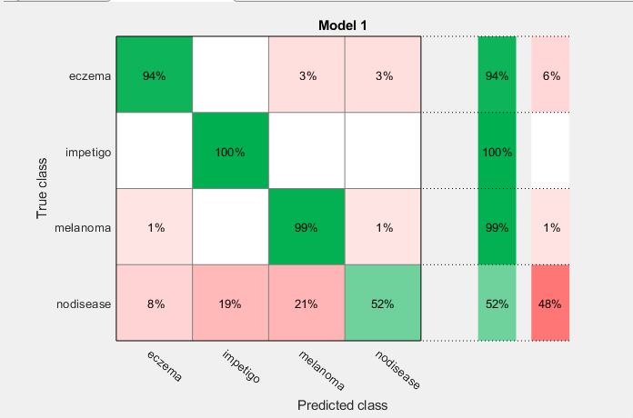

Fig -7: SVM Confusion Matrix

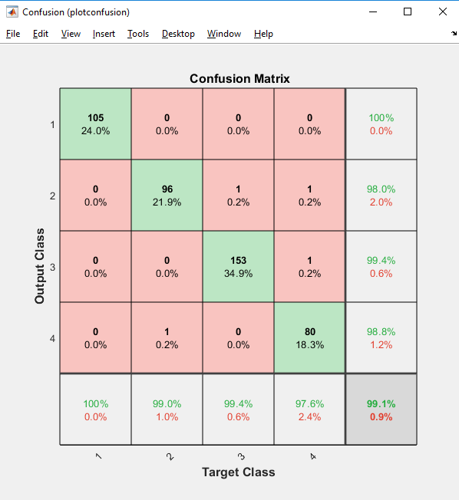

Fig -8: CNN Confusion Matrix

5. CONCLUSION

This Paper gives the solution for detecting 3 skin diseases i.e melanoma, eczema, impetigo using Image Processing with SVM classifier and CNN classifier. Comparison between CNN and SVM Classifier is done with the help of the confusion matrix and the detailed table showing the accuracy of both the classifiers. According to the result obtained, CNN classifier proved to be accurate and efficient in detecting skin disease as compared to SVM Classifier.

FUTURE SCOPE

Future scopes of improvement in present methodologies are:
1. A common model should be adopted for the identification of all types of skin diseases
2. Support for multilingualism to develop user-friendliness
3. To expand the multiplatform capability through an introduction to IOS compatibility

ACKNOWLEDGEMENT

We owe our deep gratitude to our project guide mentor, Mrs. Jayashree Hajgude (M.E.) Asst. Professor, VESIT, who took a keen interest in our project work and guided us all along, till the completion of the project by providing all the necessary information to us. The success and final outcome of this project required a lot of guidance and assistance from many people and we are extremely privileged to have got this pearls of wisdom shared with us by our mentor during the course of this research.

REFERENCES

- Nisha Yadav, Virender Kumar Narang, Utpal shrivastava, “Skin Diseases Detection Models using Image Processing”, International Journal of Computer Applications (0975 – 8887) Volume 137 – No.12, March 2016.
- Er.Shrinidhi Gindhi, Ansari Nausheen, Ansari Zoya, Shaikh Ruhin, “An Innovative Approach for Skin Disease Detection Using Image Processing and Data Mining”, “International Journal of Innovative Research in Computer and Communication Engineering (IJIRCCE)”, April 2017.
- A.A.L.C.Amarathunga, E.P.W.C. Ellawala, G.N. Abeysekara, C. R. J. Amalraj, “Expert System For Diagnosis Of Skin Diseases”, “International Journal Of Scientific & Technology Research Volume 4, (IJSTR)”, January 2015.
- Amrutha Ravi, Sreejith S, “A Review on Brain Tumour Detection Using Image Segmentation”, “International Journal of Emerging Technology and Advanced Engineering (IJETAE)”, June 2015.
- Aswin.R.B, J. Abdul Jaleel, Sibi Salim3, “Implementation of ANN Classifier using MATLAB for Skin Cancer Detection”, International Journal of Computer Science and Mobile Computing (IJCSMC), December 2013.
- Rahat Yasir, Md. Ashiqur Rahman, Nova Ahmed, “Dermatological Disease Detection Using Image Processing And Artificial Neural Network”, 8th International Conference On Electrical & Computer Engineering, December 2014.
- Jainesh Rathod, Vishal Waghmode, Aniruddh Sodha, Dr. Prasenjit Bhavathankar, “Diagnosis of skin diseases using Convolutional Neural Networks”, IEEE, November 2018.
- [8] Yanhui Guo, Amira S. Ashour, Lei Si, Deep P Mandalaywala, “Multiple Convolutional Neural Network for Skin Dermoscopic Image Classification”, Institute of Electrical and Electronic Engineers(IEEE), 2018.
- Aneta Kartali, Miloš Roglić, Marko Barjaktarović, Milica Đurić-Jovičić, “Real-time Algorithms for Facial Emotion Recognition: A Comparison of Different Approaches”, Institute of Electrical and Electronic Engineers(IEEE), November 2018.
- Archana Ajith, Vrinda Goel, Priyanka Vazirani, Dr. M. Mani Roja, “Digital Dermatology Skin Disease Detection Model using Image Processing”, Institute of Electrical and Electronic Engineers(IEEE), 2017.

